IDC30BT WIL REPORT

LECTURE: MR MOETI

STUDENT NAME: KS MAROBE  
STUDENT NUMBER: 212319368

SECOND SEMESTER 2016

TABLE OF CONTENT

INTRODUCTION……………………………………………….………….1

BACKGROUND……………………………………………….…………...2

CONTINUEATION OF BACKGROUND………………………......3

PERSONAL ROLE AT WORKPLACE………………………………..4

CONTINUEATION OF PERSON ROLES….……………………….5

***INTRODUCTION***

My name is Kopano Salaminah Marobe, a student at Tshwane University of Technology (TUT). I am currently doing my experiential learning at TUT Polokwane Campus under ICT Services. I am a student assistant under Mr PJ Kubyane who is my employer. My experiential learning is a 6 months course / program and I started on the 1st July 2016.

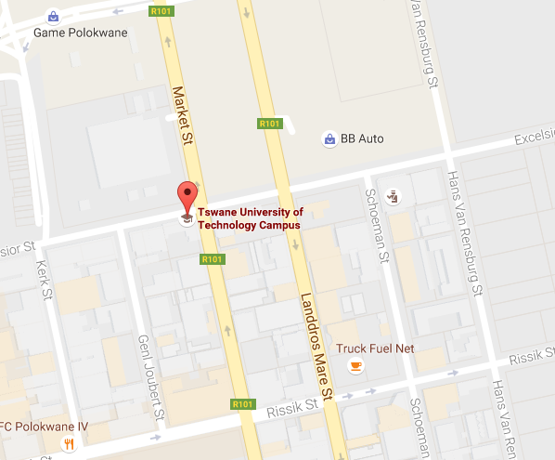

***BACKGROUND***

**The nature of the work performed by your section/department:**

The ICT Services department in TUT Polokwane Campus is support based. This department assist users on First Line Support. First Line Support is assisting users in any kind of problem. This department also has a Second Line Support which is based in TUT Pretoria campus. Here in Polokwane campus the department is basically focus on connecting users (staff members and students) to e-mails, to the domain, to access the internet and doing basic networking problems (such as: troubleshooting and tracing ports from our local servers).

**The department objectives:**

1. The main purpose for ICT is to enable the institution to achieve its mission and strategic business goals and objectives and its pursuance for excellence.
2. Hence the role of ICT Services is to support and enhance the business functions and operations of the TUT through the effective and efficient and innovative application of ICT.
3. ICT Services will, through clearly defined service levels, be a highly accessible, responsive and client-centred partner to the Institution, providing Dependability, Alignment, Innovation and Cost Effectiveness.
4. Connects administrators, faculty, staff, and students in our network by: organizing regional and global conferences to share ideas, encourage collaboration, and expand impact.

**The nature of your work area:**

The nature of my work area is to work in enclosed environment (offices) with assisting staff member and students at TUT. I assist them in overcoming any difficulties they may be experiencing (e.g. printers failure, poor PC performance, etc.). I also perform daily checks on all ICT equipment to sure it is in a acceptable working order.

**A statement of your duties:**

1. Putting a computer on the domain
2. Formatting a machine
3. Installing operating systems
4. Installing drives
5. Connecting the printer
6. Sharing a printer
7. Installing software
8. Configuring a scan
9. Configuring network
10. Updating the electronic notice board
11. Cloning lab computers
12. Connect the hub, switch and route
13. Configuring SMTPS scanner
14. Changing network cables
15. Connecting video conferences
16. Set-up outlook
17. Setting-up emails
18. Building a computer
19. Fixing DHCP Server
20. Setting up software for labs

***Personal Role at Workplace***

1. **Technical details of your work**
   1. How to installing Operating System (OS) from new disk:

* Restart your computer and press Fn + F2 to select where you want to boot your computer DVD/CDROM.
* Choose partitions
* Name the computer
* Change the time zone and the install.
  1. Activating administrator and putting a computer on domain:
* Before you put it on domain you must
* Activate the Administrator Account
* Create a password for the administrator account
* Putting the Computer on domain
* Go to “This PC / Computer” right click, then select “Properties”
* Change settings (from WORKGROUP to DOMAIN)
* Change computer name
* Then restart the computer
* After putting it on the domain
* Logon as administrator
* Go to user account and click “manage user account”
* Add a new user in the computer setting (a user who is available “TUT Active Directory”)
* Give administrative rights
  1. Putting a new user on a computer which is already on domain
* Firstly remove the computer from domain to WORKGROUP and then restart the computer
* Log-in as administrator and follow the steps of putting a computer on domain starting from “Putting the Computer on domain”
  1. Installing Network Printer
* Identify the printer and its model
* Check for the drives on the internet
* Check the computer’s OS
* Download the correct drivers
* To install the printer go to “Devices and Printer”
* Add new printer
* Select local printer then create a new port
* Select the “standard TCP/IP Port”
* Enter the printer’s IP Address
* Then install the drives and set the printer as default
  1. Sharing a printer
* Firstly check the IP Address of the computer which is already connect to the printer
* Then on that computer allow the printer to be shared
* On the new user’s computer go to “devices and printers”
* Right Click on the printer you want share and go to “printers properties”
* Then click on “sharing” and check the box that says "Share this printer". Then, you can edit the share name of the printer, in case you don't want to use the default name provided by Windows.
  1. Configuring a scan and printer
* Select devices and printers then right click on the printer or scanner that you want to configure.
* Select printer properties then click on ports.
* Click on the configure ports, update drivers and customize your hardware.
* Configure the options according to your needs.
* Click ok to save your configuration choices.
  1. Cloning lab computer
* On the one computer we install all the required software: Operating System, Microsoft Office, Acrobet Adobe, Visual Studio, and Anti-Virus.
* We insert the clonezillia disk on to the computer and make it a source computer, the code it o clone everything on that computer and send it to another computer (the target computer) over the network.
  1. Setting-up emails
* Firstly check if the user details are available on Tshwane University of Technology (TUT) active directory server by calling TUT Help-desk.
* The use the user’s user name details to log-on Outlook and the required password.
  1. Connecting (making a call) via Video Conferencing
* Switch-on the screen monitor
* Select make a call button
* Dial the number you are requested to call

1. ***How you have applied your knowledge and skills***

* When installing the operating system I checked the system requirements because operating systems have varying system requirements
* I would decide whether to purchase or download the operating system. When purchasing it means that it will only be used once because purchasing comes with Window Licences, and some operating systems are free to download meaning you can install them as much as you would like.
* When installing a new operating system I would also backup my data, because I would most like wipe out the hard drive in the process.
* When installing a printer: I would find out the computer’s Window XP platform (e.g. 32-bit or 64-bit), and find out the make and model of the printer I am are trying to install.
* When connecting via video conference I would identify if there is internet connection, identify the individual we are call and his/he call ID number.
* When cloning lab computer: firstly I would identify any computer which is not working and remove it, then make sure that all computers are connected to the network.

1. ***The specific duties delegated to you and how accomplished them***

* Connecting 3 users to a printer: I connect the switch to the main network port on the wall then connected all 3 computers and the printer to the switch. The used one computer to mainly connect the printer and share the printer with two other computers over the network.
* Setting up software at the lab: I took one computer and installed all the require software. Then cloned the computers by make the computer with all required software a “source computer” and took another computer and made it a “target computer”.

1. ***How you worked with the other team members***

* **Put the Team First:** I work hard, develop and serve the team.
* **Build Relationships:** I would build a goodrelationship for it helped connect, communicate and care for other their team members
* **Trust and Be Trusted:** Great team members trust their teammates and most of all their team members trust them. Trust is earned through integrity, consistency, honesty, transparency, vulnerability and dependability. If you can’t be trusted you can’t be a great team member. Trust is everything
* **Be Humble** - Great team members are humble. They are willing to learn, improve and get better. They are open to their team member's feedback and suggestions and don’t let their ego get in the way of their growth or the team’s growth
* **Set the Example** - Instead of worrying about the lack of performance, productivity and commitment of others you simply decide to set the example and show your team members what hard work, passion and commitment looks like.